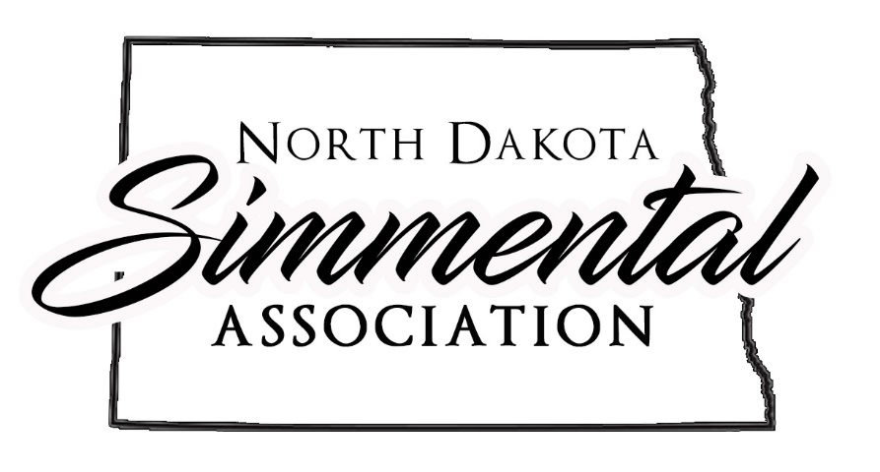
2022 North Dakota Simmental Association $250 Heifer Grant Application
Applicant: Please fill out this application yourself. Parent or guardian is to fill out the section on the other page where indicated.

Name:_______________________________________________DOB:_____________________
Address:___________________________City,State,Zip:________________________________
Phone:_____________________________

YOUTH ELIGIBLE FOR THIS GRANT MUST MEET THE FOLLOWING CRITERIA:
- Applicant must be a ND Junior Simmental Association member and a North Dakota resident to be eligible for this grant. If you are not a current member of the ND Junior Simmental Association you may join by enclosing your annual membership dues of $10.00 made payable to the ND Jr Simmental Association along with this application.
- Age: Must be at least 8 years old and not have turned 21 years old by date of the Classic Sale.
- Must be able to provide the remaining purchase price of the heifer immediately after the sale.
- Only animals purchased from the ND State Simmental Classic Sale are eligible for the grant money.
- Embryos do not qualify for the 2022 ND Simmental Association $250 heifer grant.
- Grant money will be paid directly to Kist Livestock on behalf of the grant recipient.
GRANT RECIPIENT MUST BE PRESENT AT THE 2022 ND STATE SIMMENTAL SALE IN ORDER TO RECEIVE AND USE THE GRANT IF AWARDED
(Grant recipients will be notified prior to the sale)

Return all pages to: NDSA, Kim Myers, 12066 57 St SE, Kathryn ND 58049 by December 1, 2022
*Purpose of the Grant Program is to provide quality Simmental animals to youth interested in starting or adding to their Simmental genetic herd.

Following must be completed by a parent or guardian:
As the parent or legal guardian of _________________________, I hereby agree to make sure that there are funds available to pay the remaining balance of purchased heifer immediately following the sale.
Signature of parent or legal guardian:__________________________ Date:_____________
Printed Name of parent or legal guardian:________________________

2022 ND Simmental Association $250 Grant Program is sponsored by the ND Simmental Association 12066 57 St SE Kathryn ND 58049

Grants are not transferrable and do NOT carry over to the next year.
Examples:
$3000 Purchase price of heifer
-$250 Grant (if awarded)
$2750 Cost to Junior buyer

Please return completed application by December 1, 2022 to
NDSA
Kim Myers
12066 57 St SE
Kathryn ND 58049

How Recipients will be chosen:
- Selection committee will be the ND Simmental Association Board of Directors
- No names will appear on the application portion that is submitted to the selection committee
- Criteria for judging the grant applications: dedication to the simmental breed, ability to care for the animal, sense of responsibility, integrity, how much effort was put into the application

Application must be completed by applicant only in their own handwriting. Do Not put name on this portion of the application. Failure to do so will result in disqualification.

Age:___________________
- List activities in which you are presently involved (examples: community, jr cattlemen’s association, 4H, FFA, ND Jr Simmental Assoc, American Jr Simmental Assoc, etc.)
_________________________________________________________________________
__________________________________________________________________________
__________________________________________________________________________
- At present I own________cows, ________of which are Simmentals.
- Tell us how you will pay for the balance of your animal should this grant be awarded to you (for example: borrow the money, have money in savings account, etc.)
_________________________________________________________________________
_________________________________________________________________________
- Do you intend to show this animal: Yes______ No______
- How do you plan to care for this animal (feed & housing):___________________________
__________________________________________________________________________
__________________________________________________________________________

__________________________________________________________________________

- Tell us what your reason for applying for this grant is:______________________________
__________________________________________________________________________
__________________________________________________________________________
__________________________________________________________________________
__________________________________________________________________________
__________________________________________________________________________
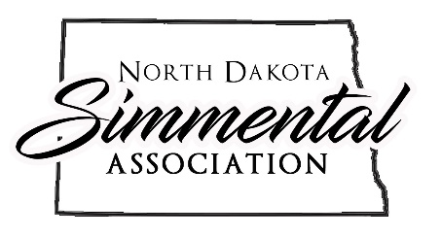
2022 ND Simmental Association $250 Grant Program is sponsored by the ND Simmental Association 12066 57 St SE Kathryn ND 58049

Please return completed application by December 1, 2022 to NDSA, 12066 57 St SE, Kathryn ND 58049 (Also, if not a current junior member, include $10 membership fee)

